**Lab 9**

**Speech and Image Processing**

**Group Members:**

**Muhammad Rehman Rabbani 137364**

**Abdul Ghaffar Kalhoro 194699**

**Hamad Nasir 120312**

Group assignment up to 3 students per group.

Using DialogFlow API, make a chat bot

**Part (a)** 2 marks

Please fill out the data creation form as shared by MS student Javeria Hassan. This will give an idea about chatbot data collection. This data will also be used by our research group.

**Muhammad Rehman Rabbani:**

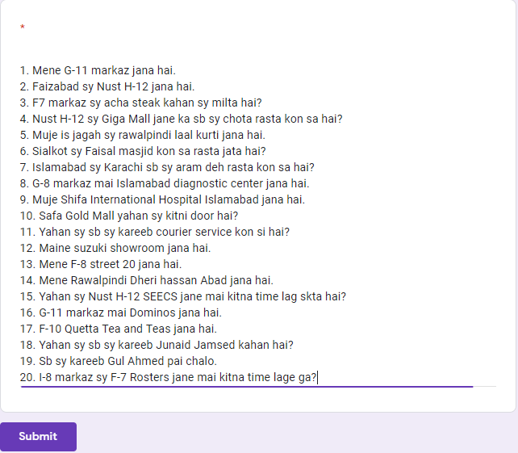

**Abdul Ghaffar Kalhoro:**

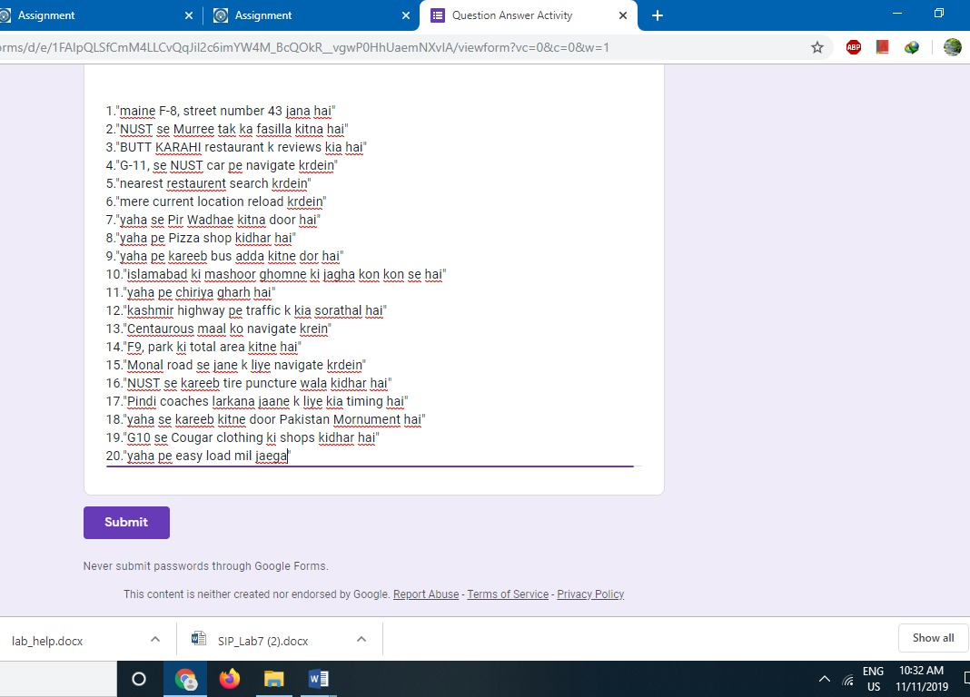

**Hamad Nasir:**

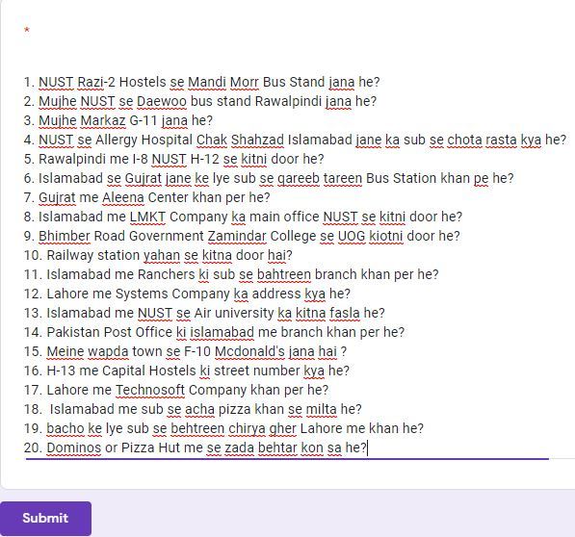

**Part (b)** 3 marks

Login to DialogFlow and run one of its existing projects (e.g. Restaurant ordering chatbot). Learn how its intent, entities, slot filling etc. work and experiment with changes.

**Part (c)** 5 marks

Create your own customer support chatbot in DialogFlow. Ideally every group should have a chatbot for a different real life application.

Example: A mobile provider package chatbot, which asks a customer about his mobile phone usage habits e.g. call minutes for within-network and out-of-network calls, SMS and internet usage GB per month. Based on this input, the chatbot suggests a suitable card/package for the customer. Try to make the chatbot non-linear i.e. the next question to be asked could be based on customer’s previous answers.

**Screenshots:**

**Chat**

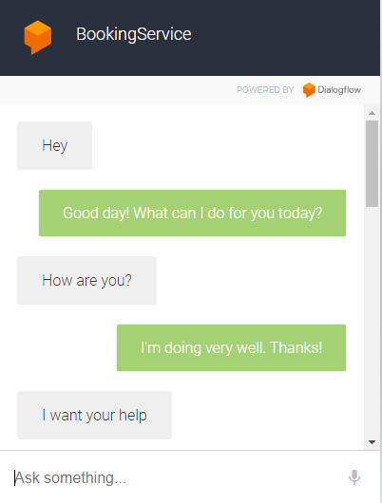

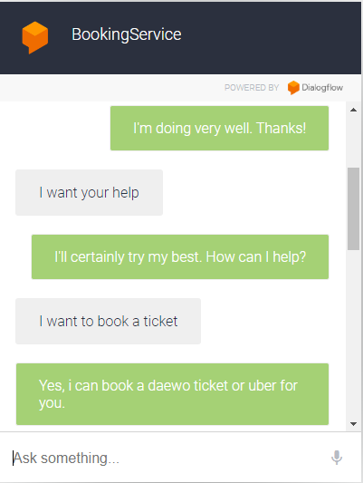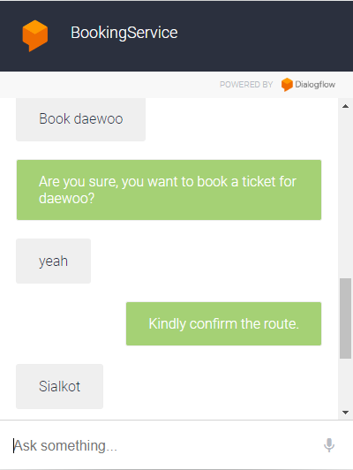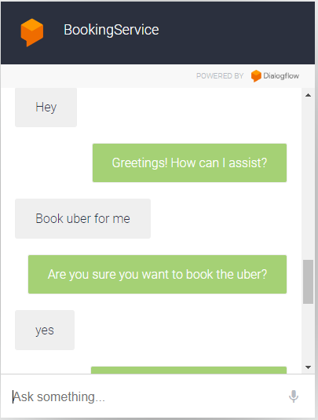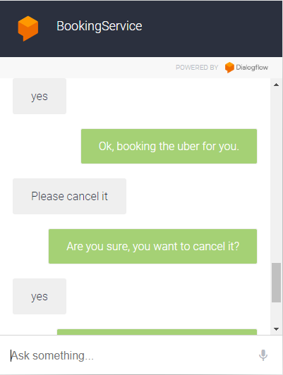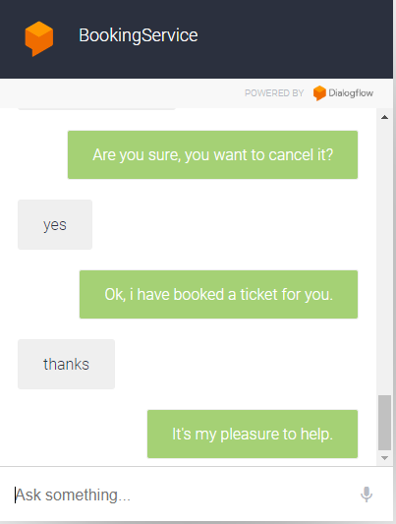

**Functionality:**

**Intents:**

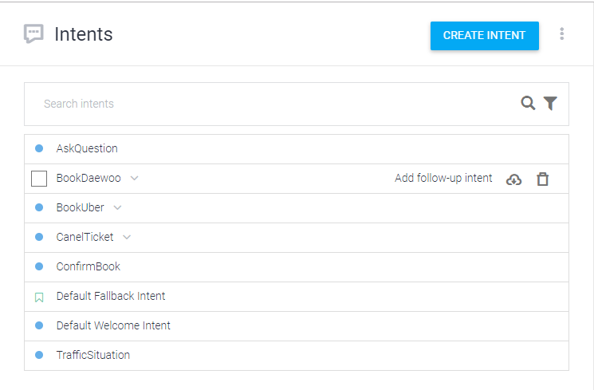

**Follow-up intents:**

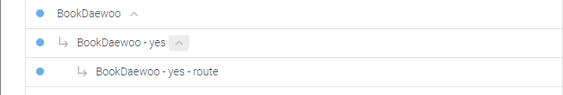

**Entity:**

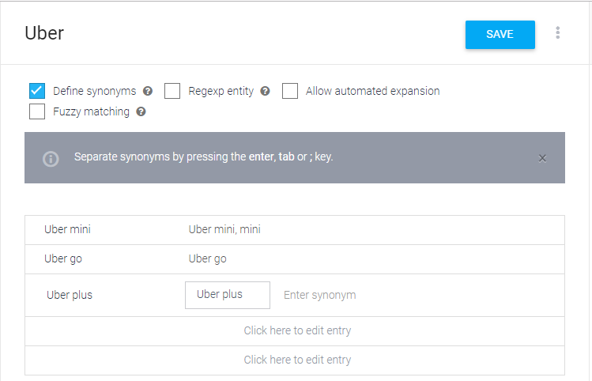

**Deliverables:**

3x screenshots of important parts of chatbot code/functionality

3x screenshots of your interaction sessions with the chatbot

Screenshot of submitted sentences of part (a)